**Chapter Five**

**Implementation**

# 5.1 Introduction:

In this chapter presents the implementation steps of the project by taking snapshots from project, and the function of apps and Classes.

# Android

Android is a mobile operating system based on a modified version of the Linux kernel and other open source software, designed primarily for touchscreen mobile devices such as smartphones and tablets. Android is developed by a consortium of developers known as the Open Handset Alliance and commercially sponsored by Google. It was unveiled in November 2007, with the first commercial Android device, the HTC Dream, being launched in September 2008.

Most versions of Android are proprietary. The core components are taken from the Android Open Source Project (AOSP), which is free and open-source software (FOSS) primarily licensed under the Apache License. When Android is installed on devices, ability to modify the otherwise FOSS software is usually restricted, either by not providing the corresponding source code or preventing reinstallation through technical measures, rendering the installed version proprietary. Most Android devices ship with additional proprietary software pre-installed most notably Google Mobile Services (GMS)[14] which includes core apps such as Google Chrome, the digital distribution platform Google Play, and associated Google Play Services development platform.

Android was founded in Palo Alto, California, in October 2003 by Andy Rubin, Rich Miner, Nick Sears, and Chris White.Rubin described the Android project as having "tremendous potential in developing smarter mobile devices that are more aware of its owner's location and preferences".[21] The early intentions of the company were to develop an advanced operating system for digital cameras, and this was the basis of its pitch to investors in April 2004.[22] The company then decided that the market for cameras was not large enough for its goals, and five months later it had diverted its efforts and was pitching Android as a handset operating system that would rival Symbian and Microsoft Windows Mobile.

Android is open to everyone: developers, designers and device makers. That means more people can experiment, imagine and create things the world has never seen.

# Firebase

Firebase is a Backend-as-a-Service (Baas). It provides developers with a variety of tools and services to help them develop quality apps, grow their user base, and earn profit. It is built on Google’s infrastructure.

Firebase is categorized as a NoSQL database program, which stores data in JSON-like documents.

Features we used in project:

1. Authentication

It supports authentication using passwords, phone numbers, Google, Facebook, Twitter, and more. The Firebase Authentication (SDK) can be used to manually integrate one or more sign-in methods into an app. And in our app we used email authentication with the email and password by bind the project with firebase and use its functions.

1. Firestore database

Cloud Firestore is a NoSQL, document-oriented database. Unlike a SQL database, there are no tables or rows. Instead, you store data in documents, which are organized into collections.

Each document contains a set of key-value pairs. Cloud Firestore is optimized for storing large collections of small documents.

All documents must be stored in collections. Documents can contain subcollections and nested objects, both of which can include primitive fields like strings or complex objects like lists.

Collections and documents are created implicitly in Cloud Firestore. Simply assign data to a document within a collection. If either the collection or document does not exist, Cloud Firestore creates it.

* Documents

In Cloud Firestore, the unit of storage is the document. A document is a lightweight record that contains fields, which map to values. Each document is identified by a name.

In our project each user has a document stored with its data and each document is identify by the user ID all users stored in collection called users

So collections have documents and documents have the actual data

We have 3 collection holding our data doctors, hospitals and users

* 1. Users for holding each user data. every user has his unique id and unique document.  
     and each document has the all user data. We save the name, email, phone, age and age and the other fields it’s result of the corona checkup questions and finally the image link to retrieve it in profile screen.

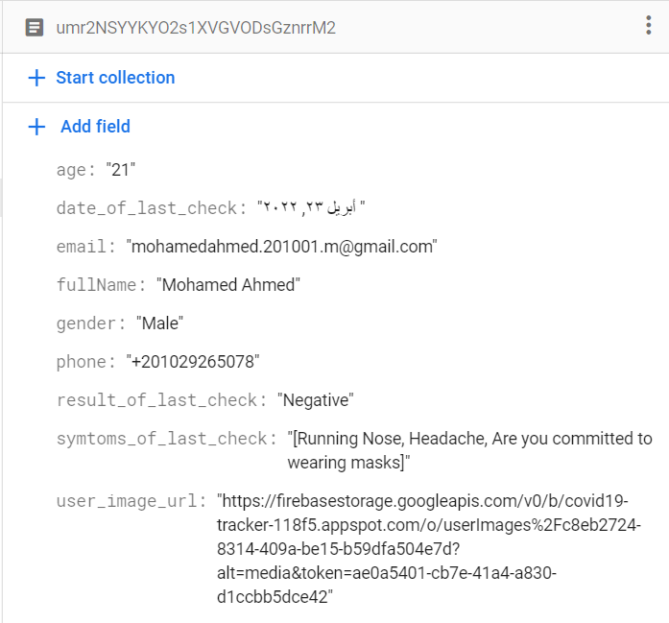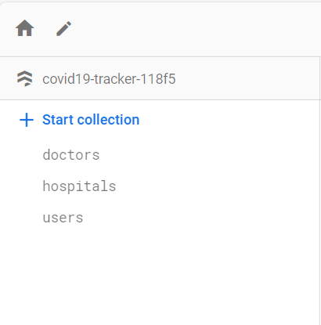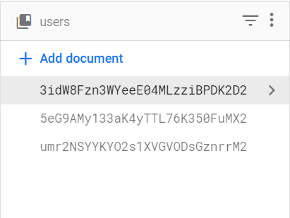

1. Doctors
2. Hospitals

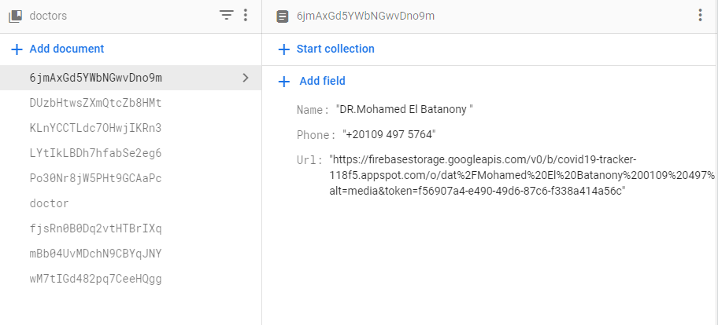

Each Data of doctor consist of (Name Phone Url of image)

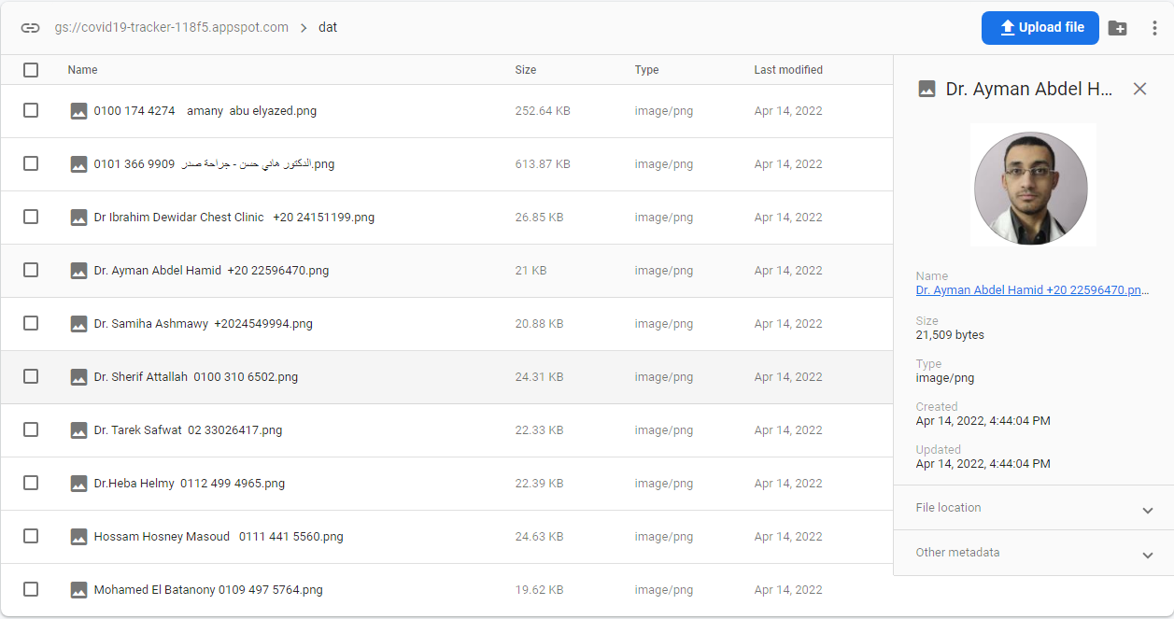

Every doctor has Url Image and invoked in our application

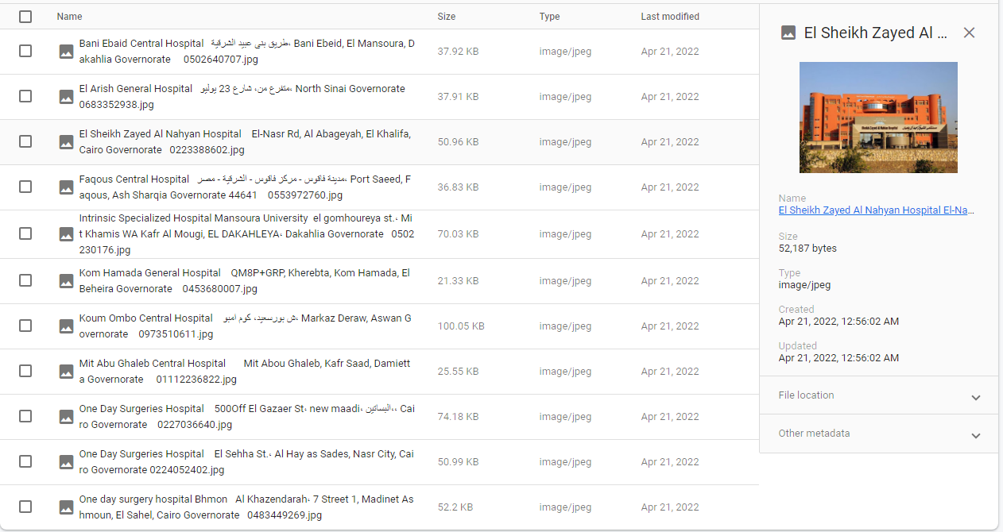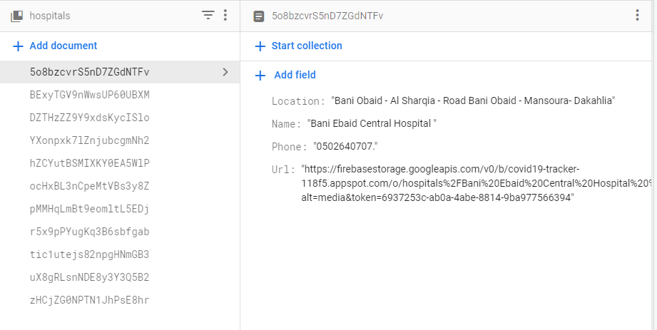Every hospital has data (Name- Location - Phone- Url Image)

every hospital has Image Url and invoked in our app in figruer()

1. 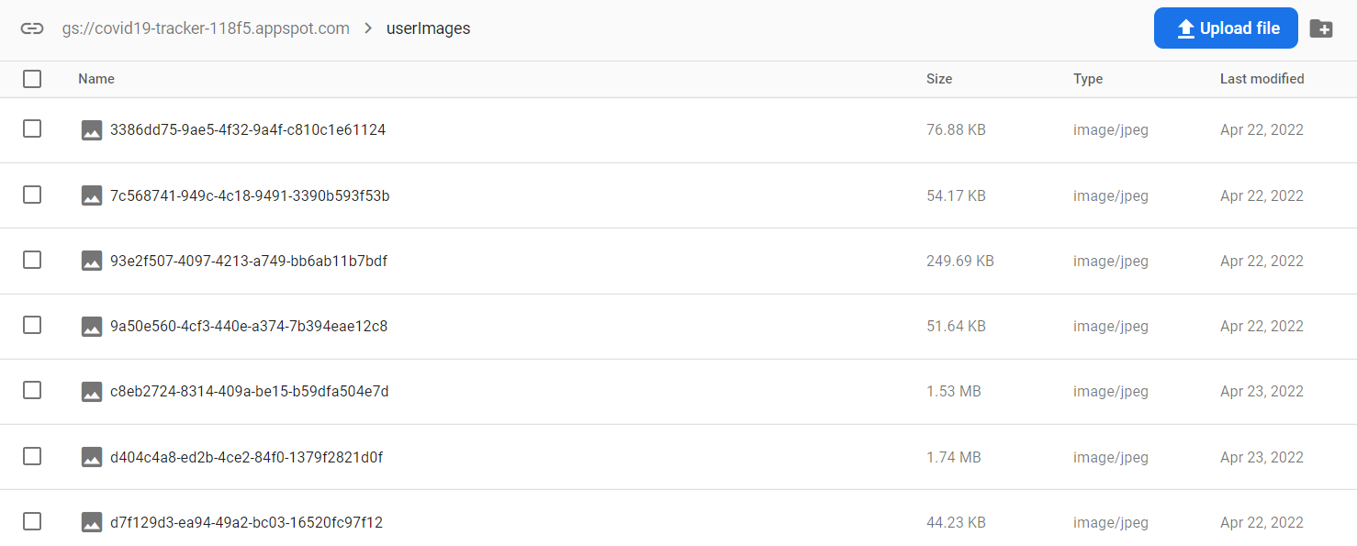Firebase Storage  
   Cloud Storage for Firebase is built for app developers who need to store and serve user-generated content, such as photos or videos. Cloud Storage for Firebase is a powerful, simple, and cost-effective object storage service built for Google scale. The Firebase SDKs for Cloud Storage add Google security to file uploads and downloads for your Firebase apps, regardless of network quality. We use storage mostly to save data. Like the user photo we upload and save it in storage then use it in our app in any time.   
     
   naser lw 7abb tdef 7aga

# API

API stands for application programming interface, which is a set of definitions and protocols for building and integrating application software.

How do APIs work?

APIs let your product or service communicate with other products and services without having to know how they’re implemented. This can simplify app development, saving time and money. When you’re designing new tools and products—or managing existing ones—APIs give you flexibility; simplify design, administration, and use; and provide opportunities for innovation.

APIs are sometimes thought of as contracts, with documentation that represents an agreement between parties: If party 1 sends a remote request structured a particular way, this is how party 2’s software will respond.

Because APIs simplify how developers integrate new application components into an existing architecture, they help business and IT teams collaborate. Business needs often change quickly in response to ever shifting digital markets, where new competitors can change a whole industry with a new app. In order to stay competitive, it's important to support the rapid development and deployment of innovative services. Cloud-native application development is an identifiable way to increase development speed, and it relies on connecting a microservices application architecture through APIs.

APIs are a simplified way to connect your own infrastructure through cloud-native app development, but they also allow you to share your data with customers and other external users. Public APIs represent unique business value because they can simplify and expand how you connect with your partners, as well as potentially monetize your data (the Google Maps API is a popular example).

Chart of how APIs work: Backend systems connect to APIs, which connect to an API management system, which connect to Apps, IoT devices and mobile.

Letting customers access data via an API helps them aggregate information about their inventory in a single place.

With a publicly available API, developers working for the book distributor, book sellers or third parties could develop an app to help customers find the books they’re looking for. This could result in higher sales or other business opportunities.

In short, APIs let you open up access to your resources while maintaining security and control. How you open access and to whom is up to you. API security is all about good API management, which includes the use of an API gateway. Connecting to APIs, and creating applications that consume the data or functionality exposed by APIs, can be done with a distributed integration platform that connects everything—including legacy systems, and the Internet of Things (IoT).

In our application we use a public api for receive corona statistics the number of cases around the world

Disease.sh An open API for disease-related statistics. We call api and retrieve the cases, recovered and deths data to make an statistic using the three values.

We use retrofit library to retrieve data from it

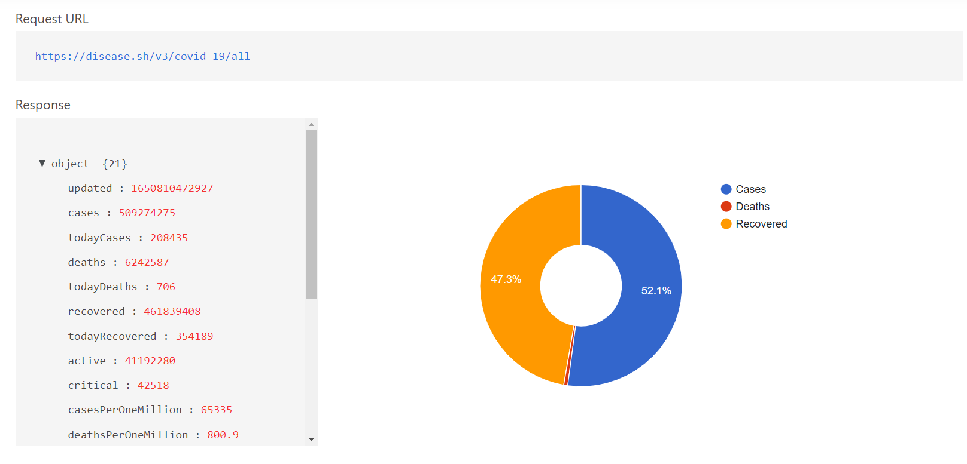

The api returns too many data we only use “todayCases”, “todayDeaths” and “todayRecovered”. Then represent it into a pie chart like we see in home screen.

We use a library called retrofit to get that data and transfer it into java object.

# Machine Model

Here we will talk about machine learning model and what were we use in our project .

We used the CNN (convolutional neural network) to classify the masked and no masked faces.

Now what is the CNN ?

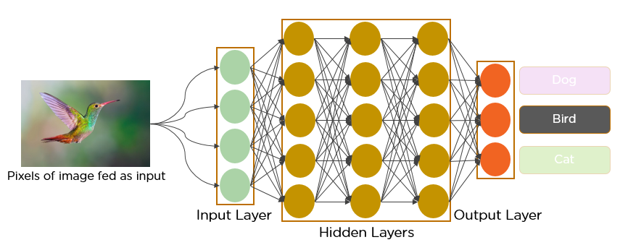Convolutional neural networks are a specialized type of artificial neural networks that use a mathematical operation called convolution in place of general matrix multiplication in at least one of their layers. They are specifically designed to process pixel data and are used in image recognition and processing.

In deep learning, a **convolutional neural network** (**CNN**, or **ConvNet**) is a class of [artificial neural network](https://en.wikipedia.org/wiki/Artificial_neural_network) (**ANN**), most commonly applied to analyze visual imagery.CNNs are also known as **Shift Invariant** or **Space Invariant Artificial Neural Networks** (**SIANN**), based on the shared-weight architecture of the convolution kernels or filters that slide along input features and provide translation-[equivariant](https://en.wikipedia.org/wiki/Equivariant_map" \o "Equivariant map) responses known as feature maps.Counter-intuitively, most convolutional neural networks are only [equivariant](https://en.wikipedia.org/wiki/Equivariant_map), as opposed to invariant, to translation.They have applications in image and video recognition,recommender systems,image classification,image segmentation,medical image analysis,natural language processing,brain–computer interfaces,and financial time series.

## Architecture of CNN

A convolutional neural network consists of an input layer, hidden layers and an output layer. In any feed-forward neural network, any middle layers are called hidden because their inputs and outputs are masked by the activation function and final convolution. In a convolutional neural network, the hidden layers include layers that perform convolutions. Typically this includes a layer that performs a dot product of the convolution kernel with the layer's input matrix. This product is usually the Frobenius inner product , and its activation function is commonly ReLU. As the convolution kernel slides along the input matrix for the layer, the convolution operation generates a feature map, which in turn contributes to the input of the next layer. This is followed by other layers such as pooling layers, fully connected layers, and normalization layers.

Now we underused the Architecture of CNN we can dive in what are we done ?

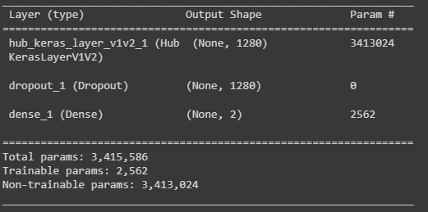

We Have 3415856 node in our CNN and we train our model with our dataset .

Our dataset Consists of two categories (Masked people –No masked people) and has 3850 photo

This screens from our dataset

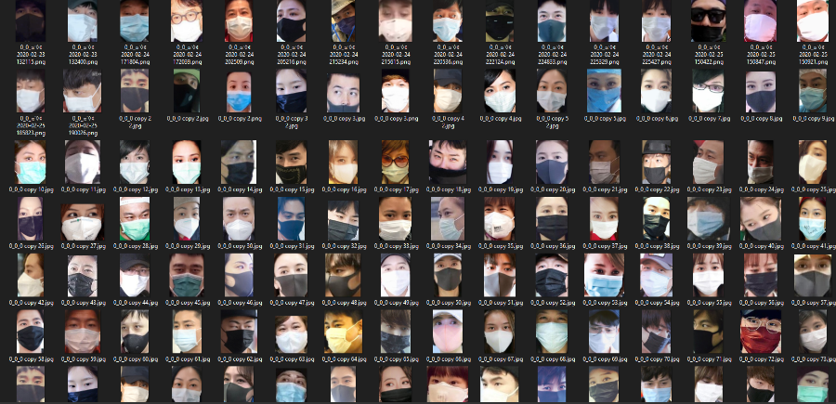

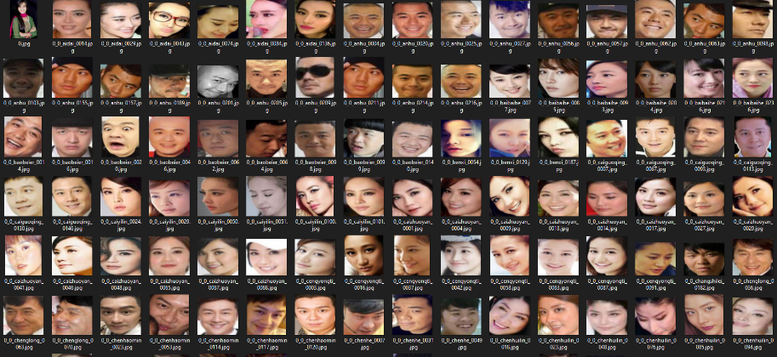

After this model we can get this results and this accuracy

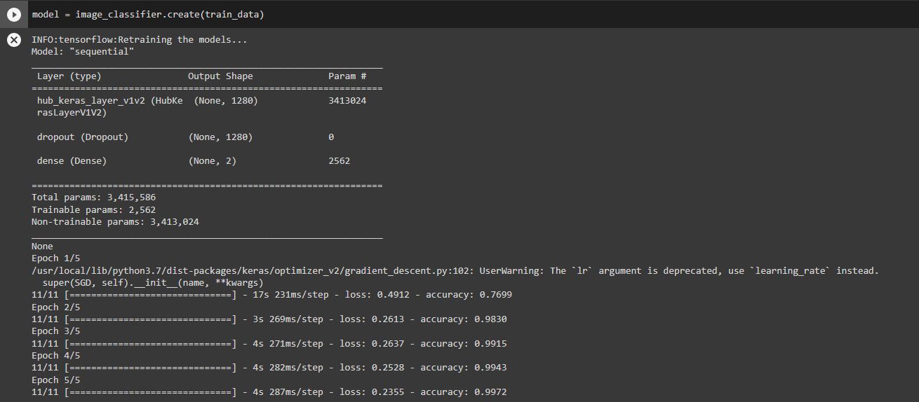

We get the last accuracy 0.9972 on training this model after 5 epoch and each epoch has 11cycle.

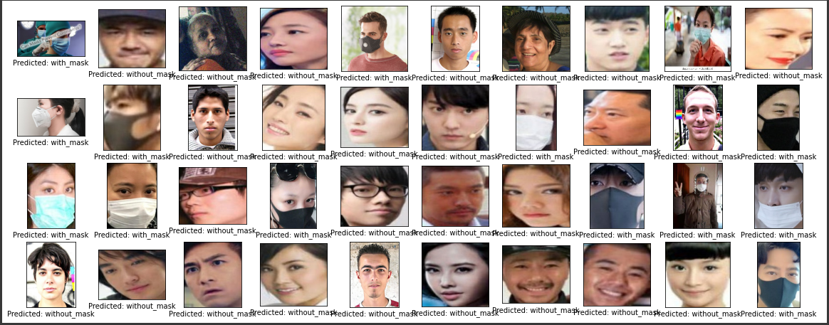

In figure ( ) we can see the test data and the prediction of model on it , we have very good accuracy .

Now should transform this model form tensor flow to tensor flow lite to work in mobile phone  
we can now used this model in our application.

# APPLICATION

-Splash activity

First we start with splash activity the purpose of it is to check if the phone connected to the internet or not with beautiful design and logo this the entrance of our app.

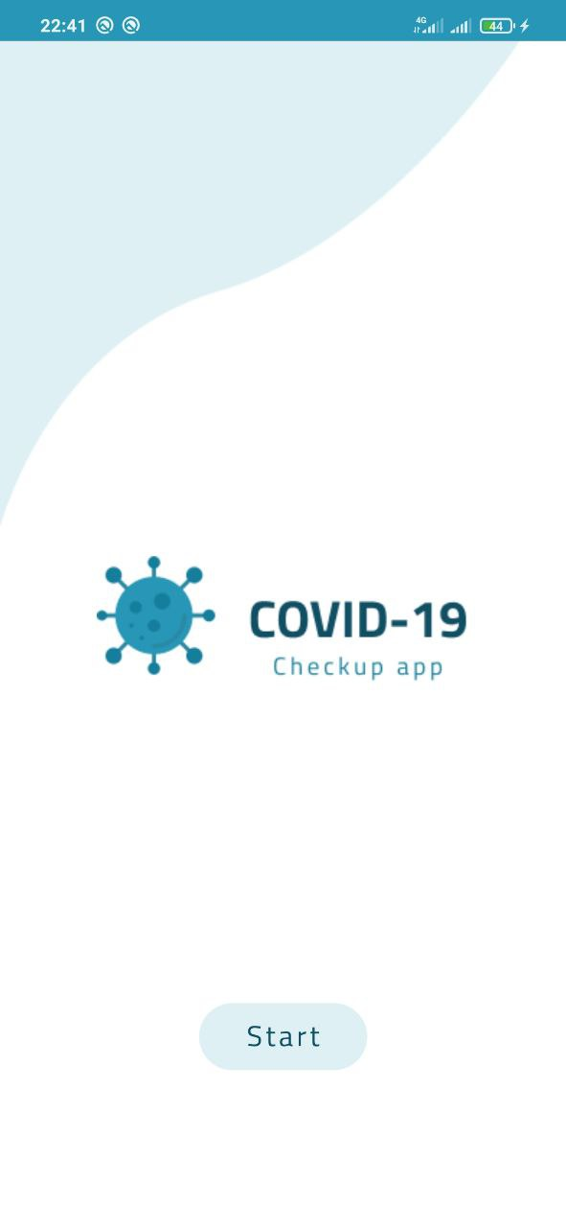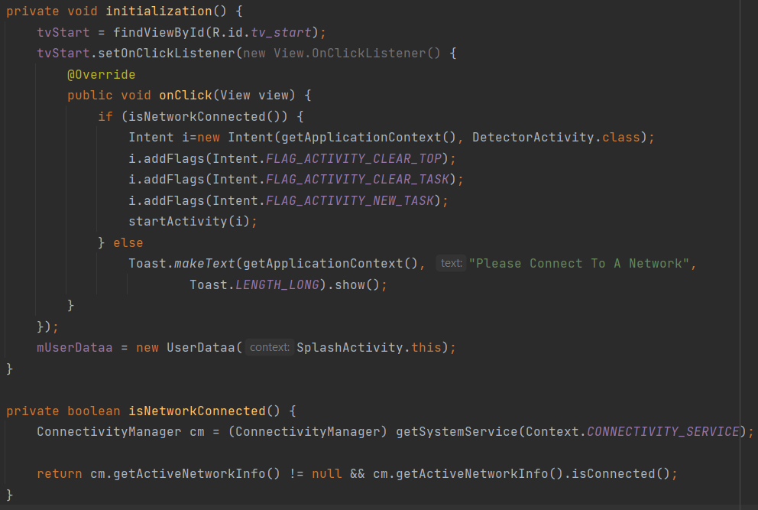It has only one button called start.

Figure 1.2

Figure 2.1

The main purpose of this screen is to check the phone is connected to a network or not so:

1. We intiate the views
2. Check the network by using isNetworkConnected function
3. If connected navigate to cam activity
4. If not print toast

## -Camera Activity

This Activity uses to check if he/her is wearing facemack or not, if not this app not opened to Login Activity .

Firstly it asking the user to give the permission to access phone camera , after this open on the front camera and detect if are you wearing the mask if not your face rounded by red rectangle and the top of this rectangle has the percentage of this face of not wearing the mask.

If the user wearing the mask , his face will rounded with green rectangle and the top of this rectangle has the percentage of this face of wearing the mask.

If the face of the user has the blue rectangle that mean it in confusion area and you should clear the lens of camera to see you clearly and wear the mask in right way.

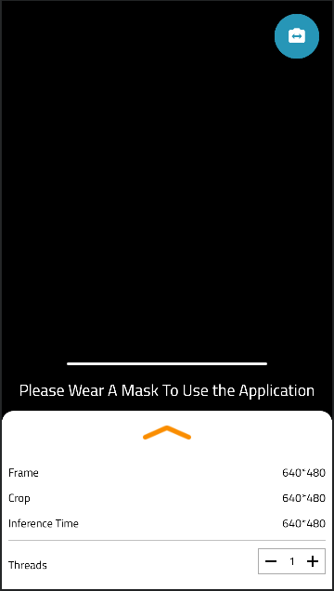

Figure 1.3

This app does’t used one time to check it used several times to ensure that the user wearing the mask

And if the wear out the mask in this operation will be stop and the line tells the user if he/her is near to complete the check.

You can look at Figure 1.3 to see what we talk about ?

if the front camera have issue or noisy by click on the switch button to access the back camera if he user want.

In figure 1.4 we can see the implementation of the switch button .

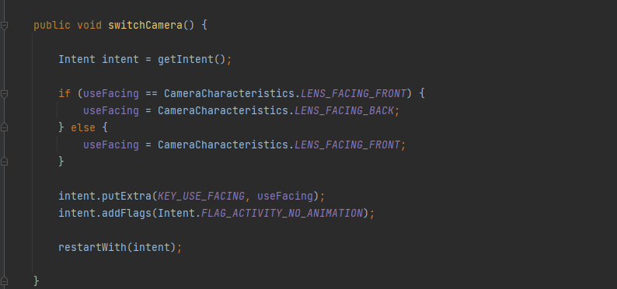

Figure 1.4

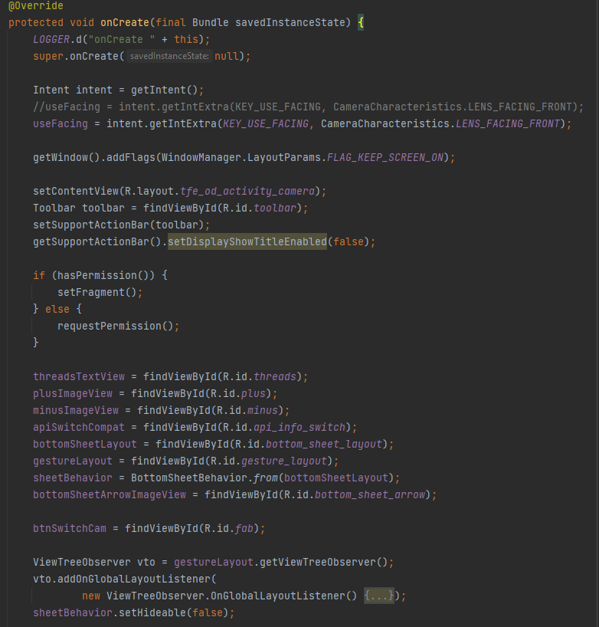we will get snapshot of code to

Figure 1.5

explain the idea not all impleme-  
-ntation .

now we will dive in all onCreate   
function in our code (Figure 1.5).

In first we are asking to check   
if our application the the   
permission to access the camera   
or not

After this go to get the IDs of   
XML file to get access our   
Design.

After getting IDs of XML,  
we used JAVA to customize   
our Design to get access hardware

Camera to layout on XML

After reserving IDs to variable in JAVA class used function onImageAvailable to make preprocess operations on image before display it on layout in XML file.

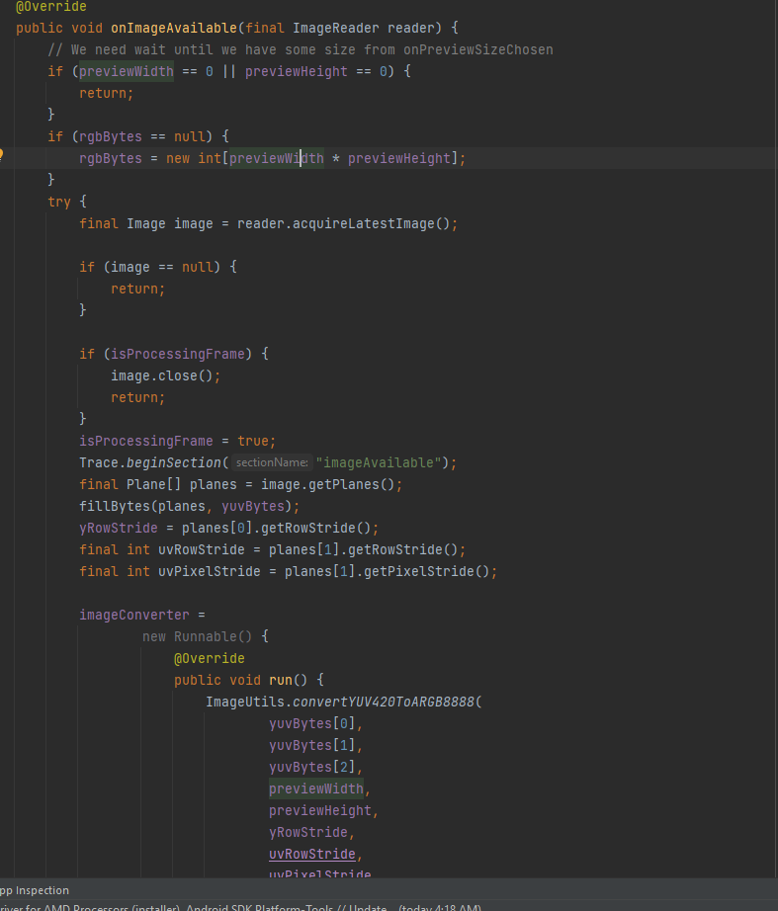in Figure 1.6 the onImageAvailable  
used to get the image from sensor  
camera and saved in variable on  
memory and invoke the function   
processImage.

In this function , we to make some   
operation on image and it is invoked   
from DetectorActivity Class in java

Figure 1.6

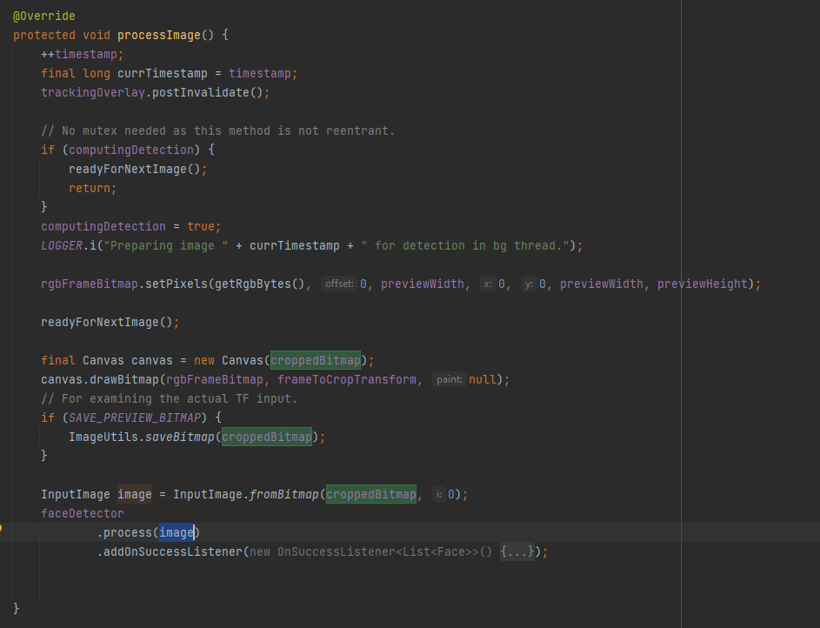

Used to Data type of convas  
to get drow in image and

Transfer it to bitmap after this   
transformation this image go to   
Class faceDetector to check this is  
 face or not and return the image .

Figure 1.6 explain what are we taking about?

Figure 1.7

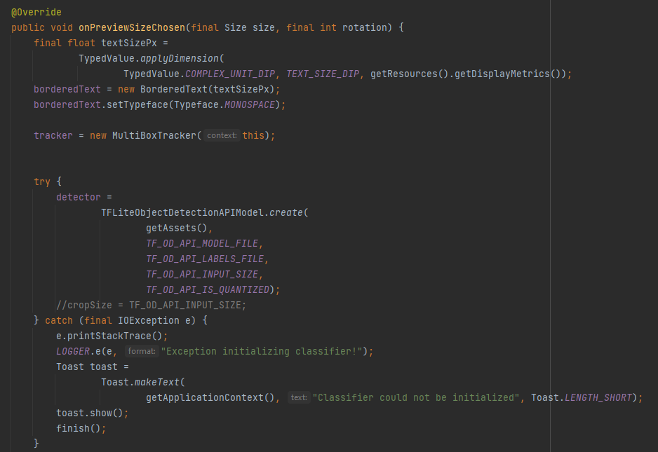

in figure 1.8 we implement onPreviewSizeChosen  
Function to initiate tracker to track faces which   
captured by class detector.

And initiate model to get be implemented on faces   
to check he/she is wearing mask or not   
 we initiate in try catch function to ensure the model   
is initiated and ready to be used without errors .

Figure 1.8

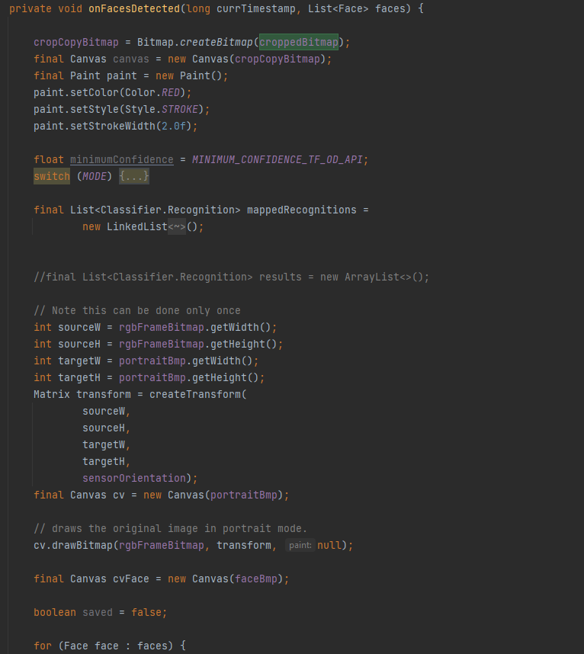  
  
in figure 1.9 this functions invoked by list of faces   
needed to be check who wear mask and who don’t  
 wear mask.

Figure 1.9

We initiate variables and same API   
to get Access Camera , and we initiate the list of class   
Classifier.

After this we loop in list of faces to detect   
people with mask and without mask   
and initiate to get draw on source image   
and initiate the matrix to restore the orientation  
transform it by get source , target and the angle   
that which has orientation to remove this issues.

We transform to get the default orientation

And apply the model on it to get the best result.

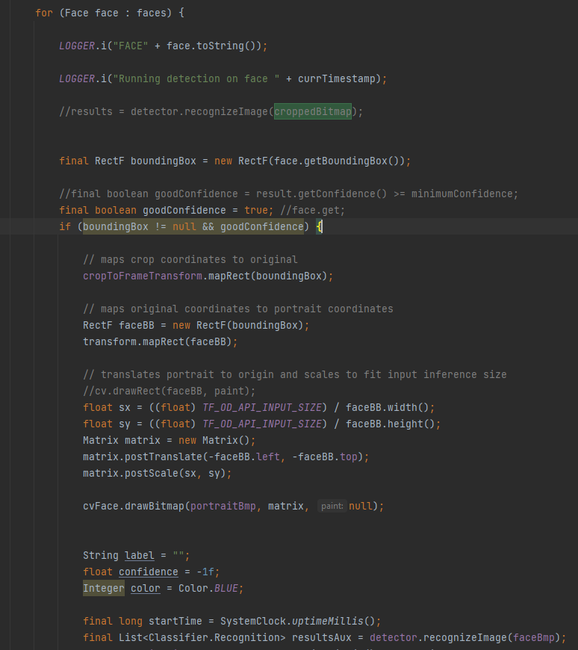

Figure 1.9.1

As we see in figure 1.9.1 we loop on list of   
faces , and apply the model on every face   
and get the result from it .  
now we want to check the result of   
this face to inform this face wearing the mask   
, not or not sure .  
  
  
after this we implement same important   
operations to get clear and real result   
and save the confidence of every face   
to be checked in figure 1.9.2.

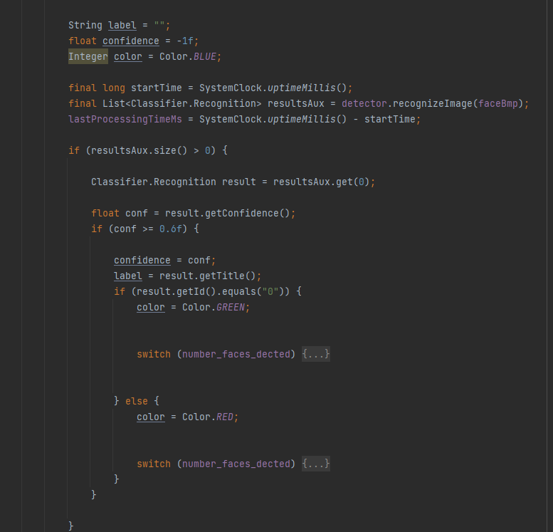we not consider the faces with confidence   
less than 60%, and we focus in greater than   
it to get the best real result .   
 now we check the matrix of [0,1]

Figure 1.9.2

if (0) this wear the mask   
if (1) this not wear the mask

wearing the mask round it by green   
rectangle

not wearing the mask round it by red   
rectangle  
not sure not wearing the mask round it by   
blue rectangle

if successful in wearing mask constrain  
, the app will go to login activity  
or home if he/she have Sign in earlier

## Authentication:

### -log in activity

We use firebase authentication in our app for manage users and registration log in activity has only two edit texts for email and password, log in button and register button for new users after check if users wear masks or not the app automatic navigate to log in. user has two options:

1. Already a user so he will just log in with his email and password
2. 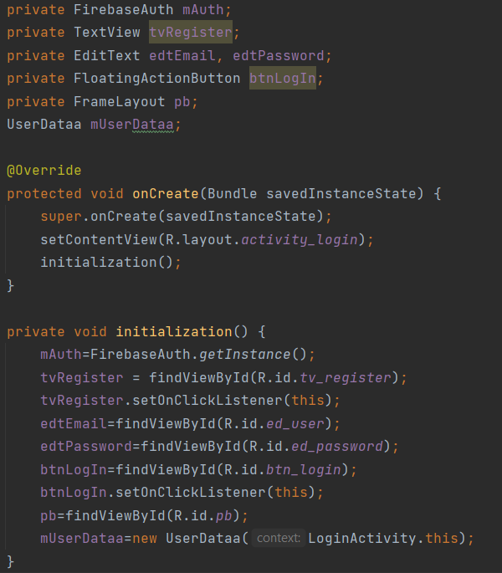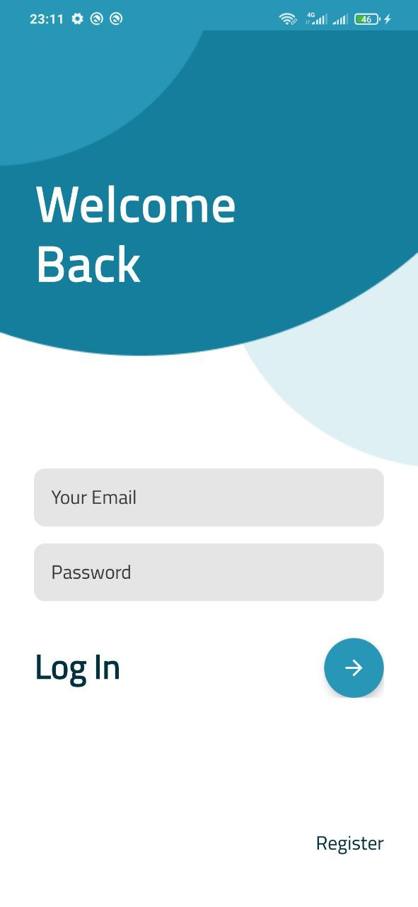New user so he will register and enter his data.

The action occurred when the floating button is pressed so we write the code in the button.

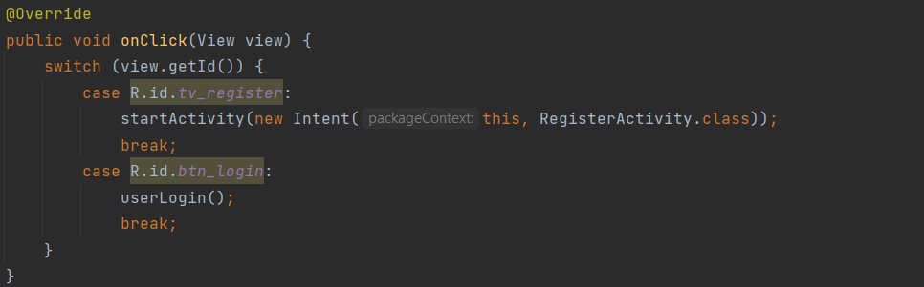After initializing views in log in activity we can access, control and handle it like getting, saving data and validate it and so on…

This is on click method we handle all click actins within log in activity on it we have the most important function in it which is userLogin(); this function doing all process to log in the user.

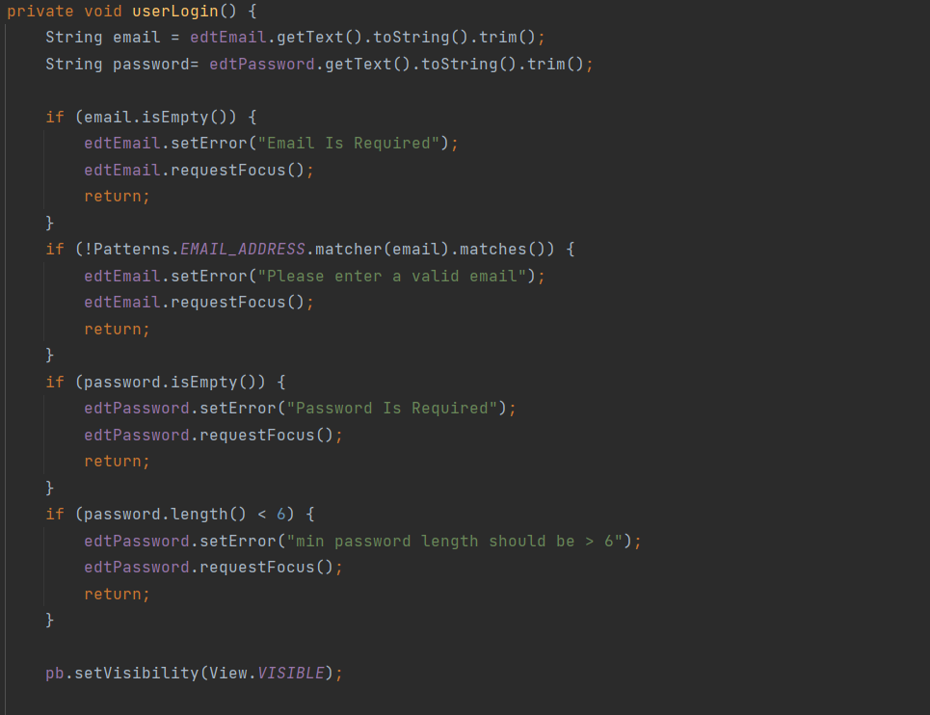

First we get the email and password from EditTexts by using getText() function, convert them into string and finally delete any spaces after or before the text by using trim() function.

Second we have some checks on the email and password that user enters it:

* is the email empty?
* is the user entre invalid email?
* Is the password empty?
* Is the length of the password less than 6 characters?

After all that checks we have an valid email, password next and final check is the email registerd , user entre the correct password and firebase will check that.

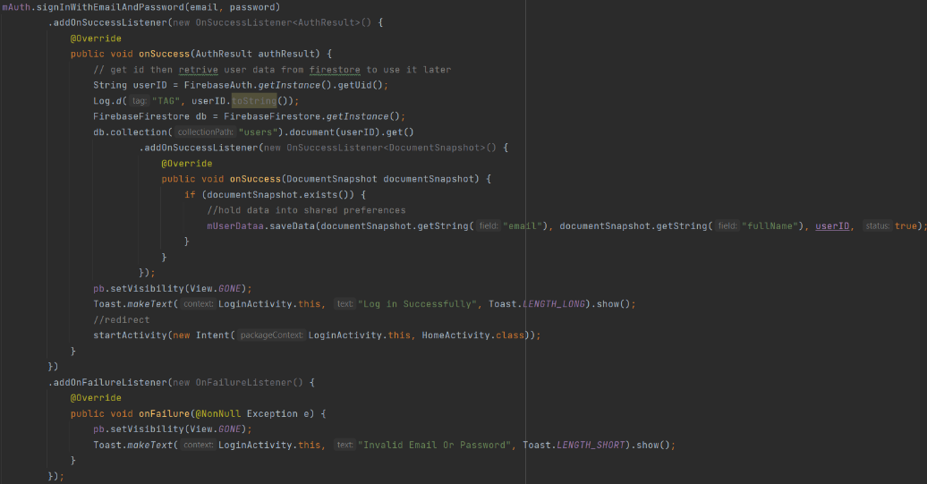we use firebase signInWithEmailAndPassword function and pass email, password to it, then it connects with firebase authentication to check the data, if the user exists and the password is correct we can log in but first we need to store some info about user so we access fire store and get some data that can be used later and store it locally in shared preferences.

* First check email and password if invalid print toast with the error
* If valid
  1. Get user id
  2. Access fire store data
  3. Get the data of the user and store it in shared preferences.
  4. Data like email, full name and id
* If not valid we get the error code from firebase by using exception

After all that steps we log in and navigate to home screen.

If the new user need to register he will just go to register activity by pressing register button it will navigate to register screen.

### Register Activity

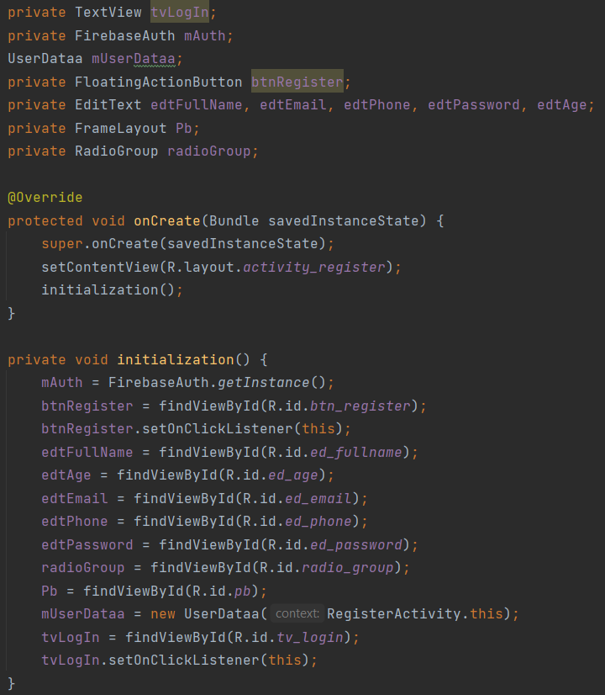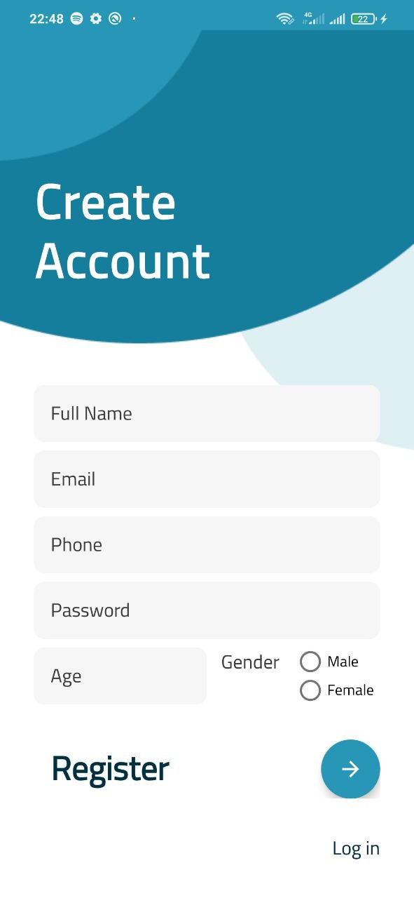The new user can easily create a new account by entre his data like his name, email, phone, password, age and finally select his gender.

The screen consists of some edit texts, floating button and log in button that navigate back to login screen.

Like the login activity we use firebase authentication and firestore to save the user data

We first start with intiate views in initialization() function and then we validate inputs like we did before.

Validation for:

1. Name if the user didn’t entre anything
2. Email if user entre invalid email
3. Phone if user entre invalid phone
4. Password if user entre short password
5. Age if user entre invalid age
6. Gender if user didn’t choose anything

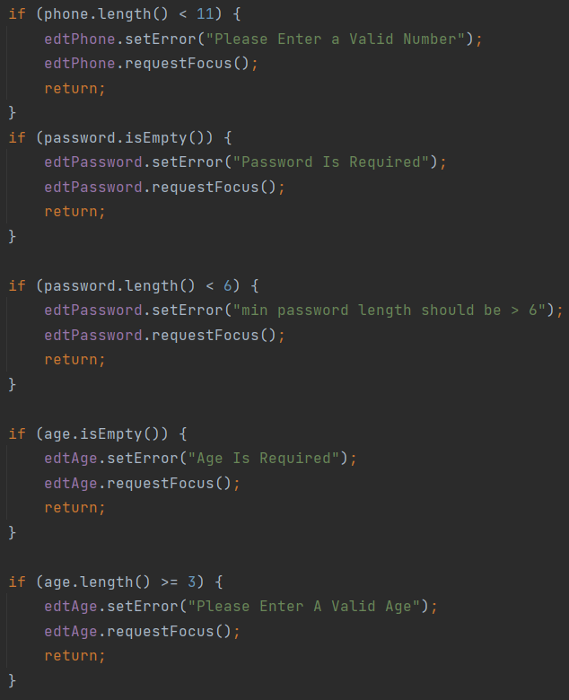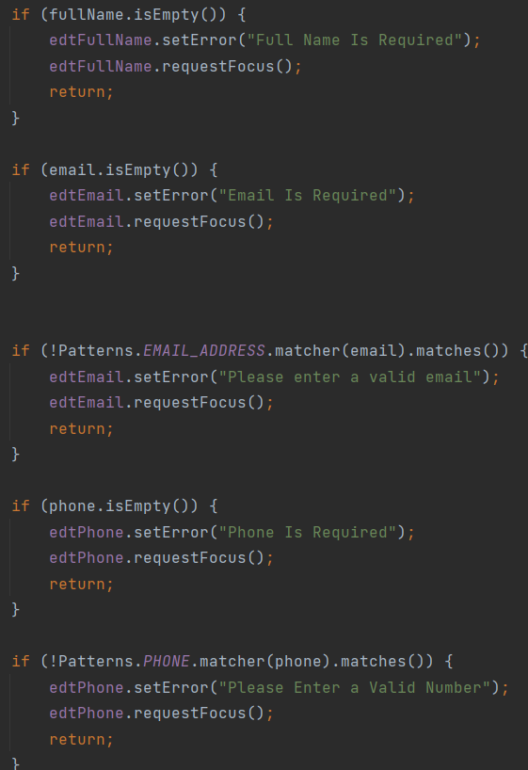

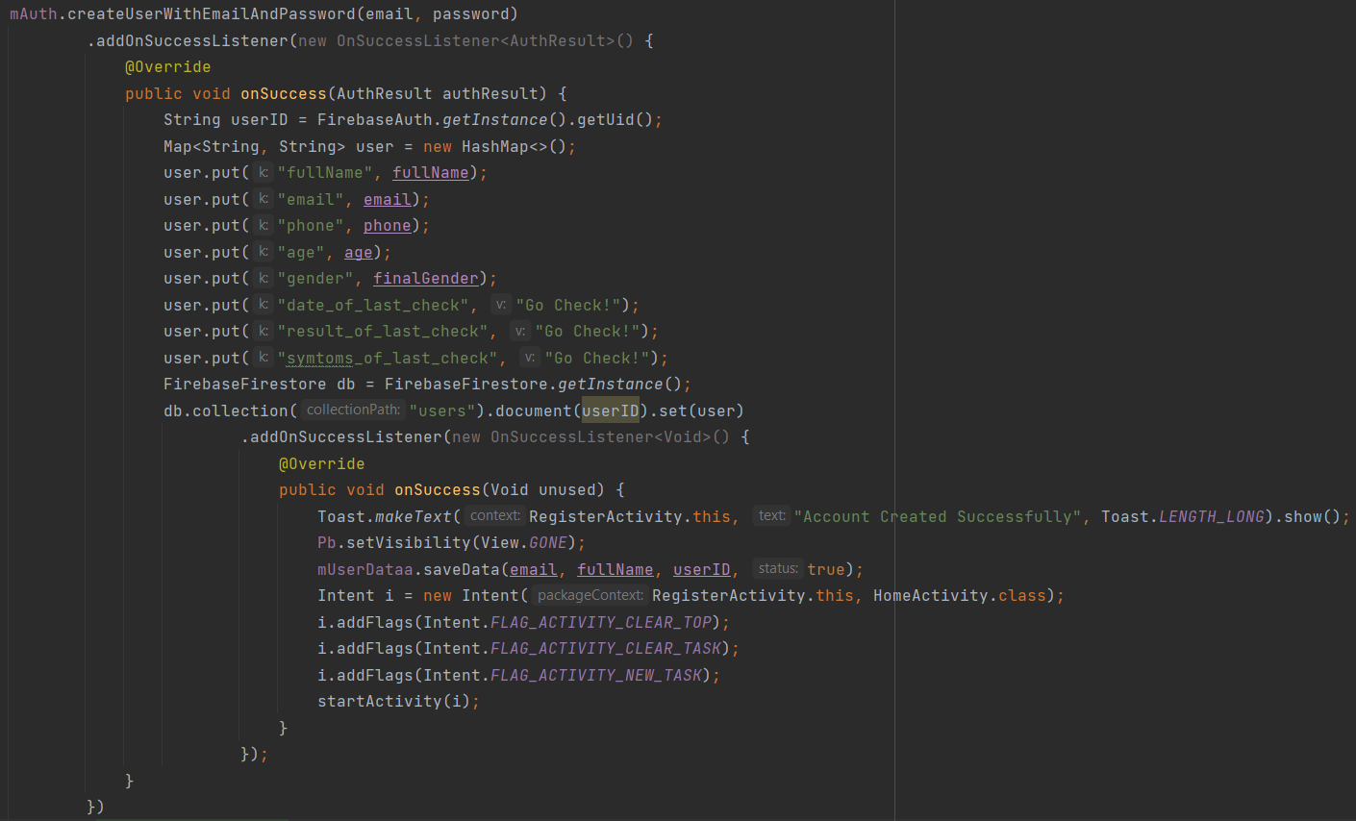After validating all data we create user using firebase createUserWithEmailAndPassword() function and it takes only the email and password so..

After creating account we save all data into firestore each user has a unique document with his id hold his data.

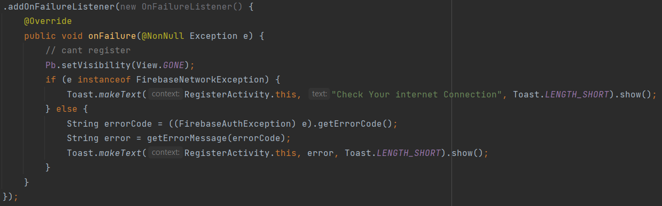If an error occurred like no connection or error in the data base we received it in onFailure method

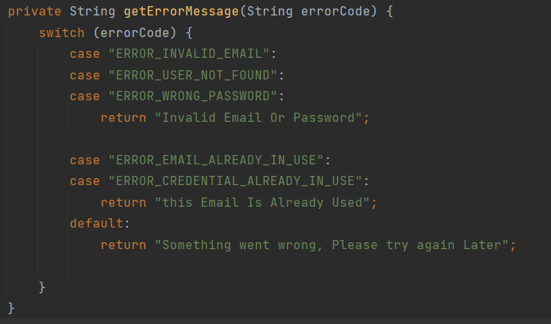We have many cases so we handle it in getErrorMessage method

After register user we navigate into Home screen that holds 3 fragments and bottom navigation view..

## Home Activity

Home screen has multi options

* first we have statistics about corona cases around the world updated every day
* self-checker we can access it by clicking on let’s check-up.
* News button
* Profile Button
* 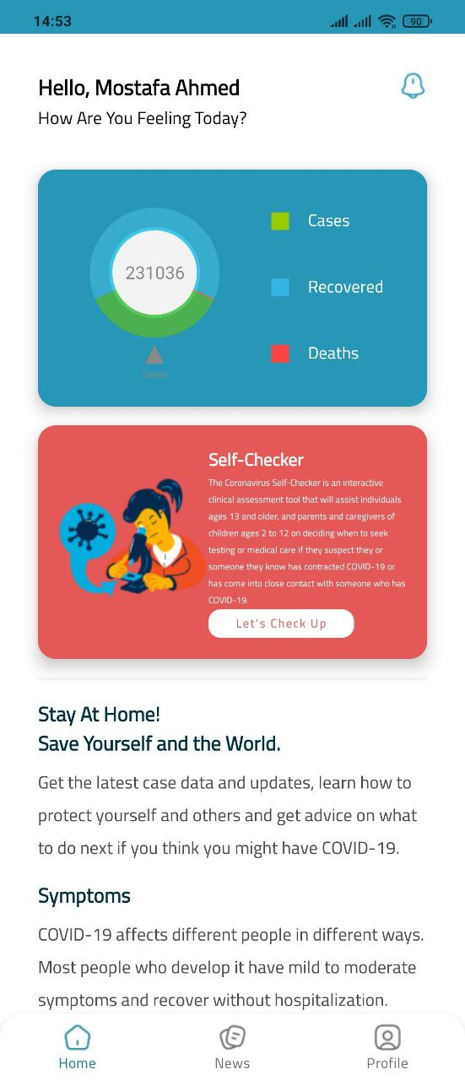Some advices

The default container in this activity is home fragment that show the statistics.

We get statistics from an public api that cover cases and updated every day. We use retrofit library to get this data. We received data as a query object and translate it into java object.

* First we have 3 classes that helps to get data from the api
  1. 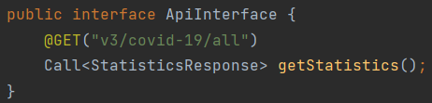An interface ApiInterface that have the get function.
  2. 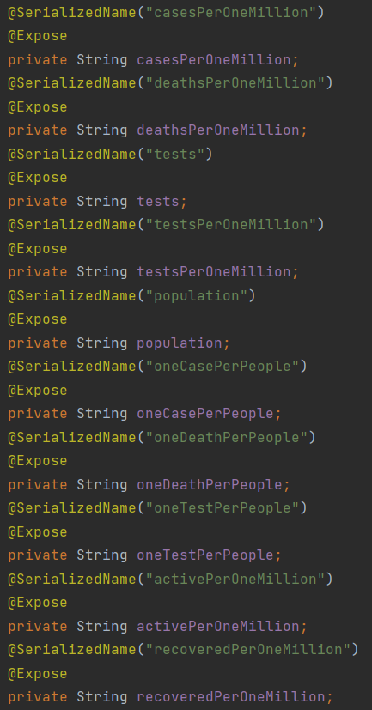StatisticsResponse class that form the data in the api. 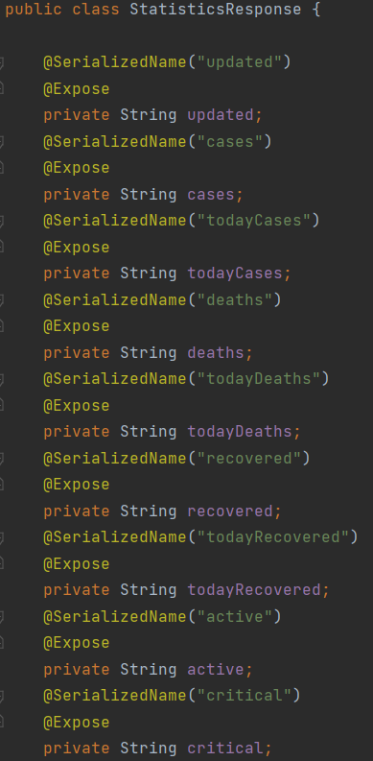
  3. WebSreviceClient class that make the call. 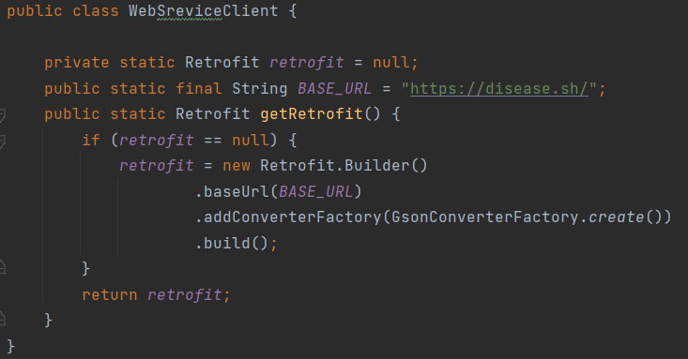

After intiating these helper classes we can easily control the data in the entire app

The home fragment holds the statistics pie chart that show 3 values

1. cases
2. recovered
3. Deaths

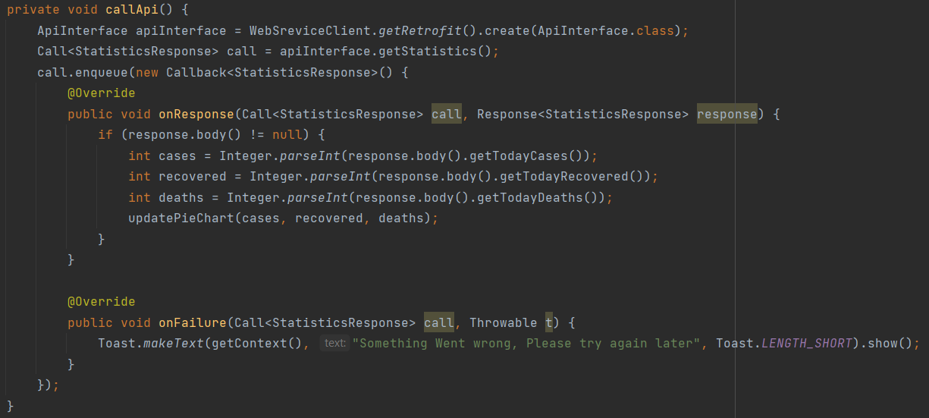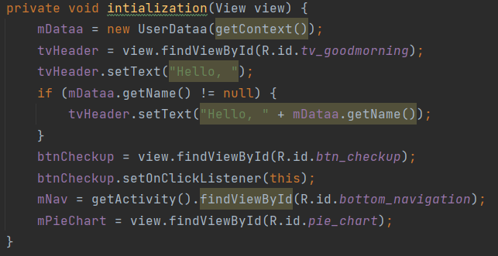After intiating views in home fragment we called a method for make the connection and retrieve the data from api.

After calling callApi() function first we make instance of the interface and we call the function that get all statistics and after get the data we parse it into integers and pass it into updatePieChart function it draw the pie chart in the screen if the connection is bad or the phone not connected a toast messege will be shown.

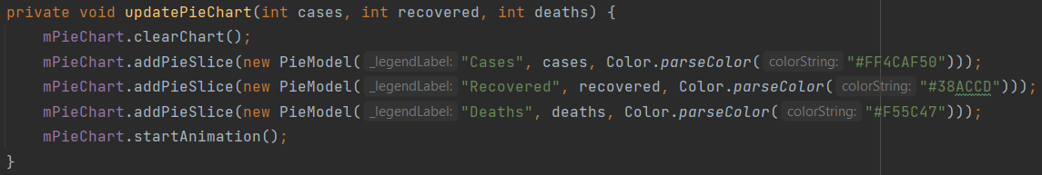

This function is only draw the results that we got from the api.

Next we have checkup button that start a few questions that determined if the user have corona or not..

Questions Screen

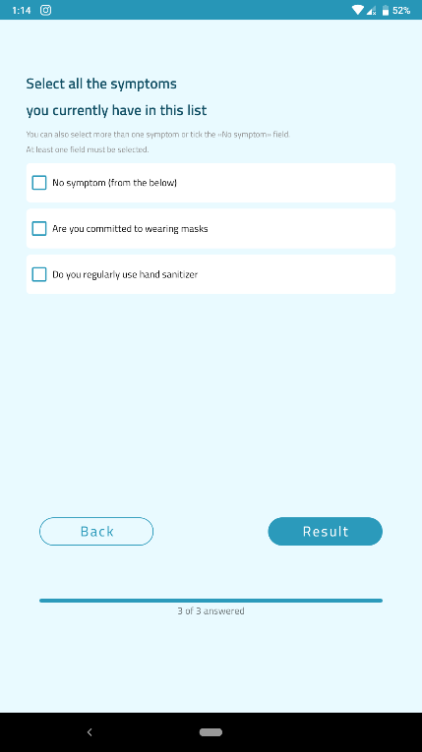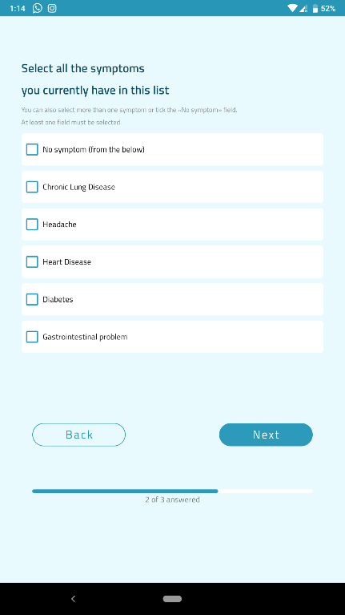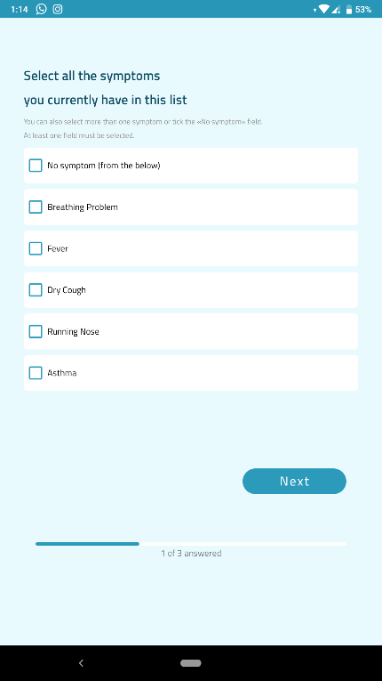

In figure ( ) we can see Questions that the application will ask the user to answering for testing   
is he/she has corona virus or not .

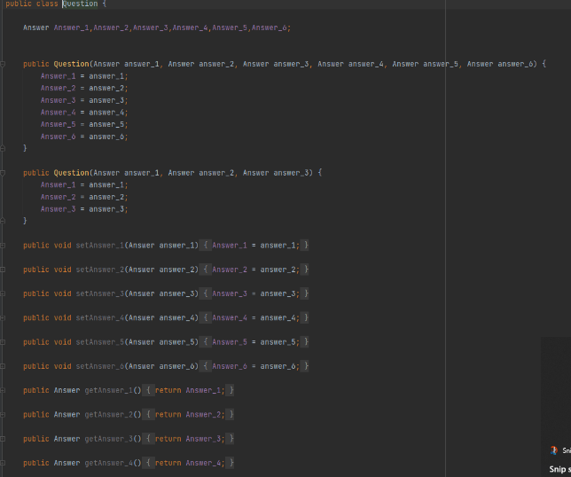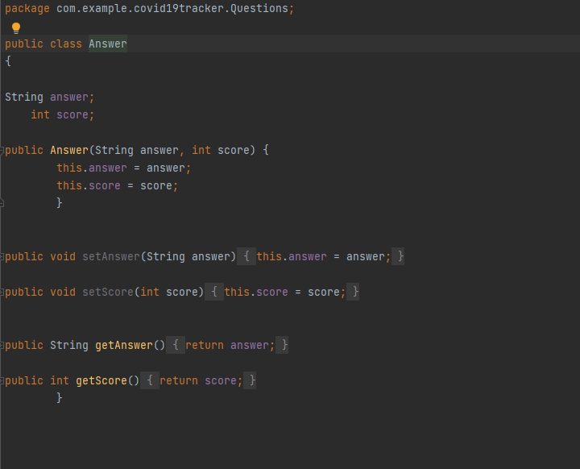

We created two class one to Answers and other to The Qustions.

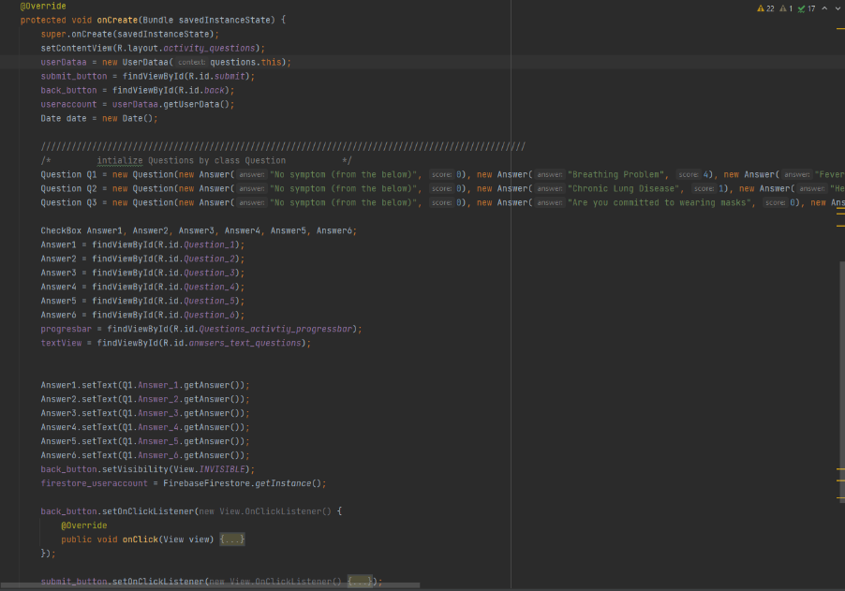

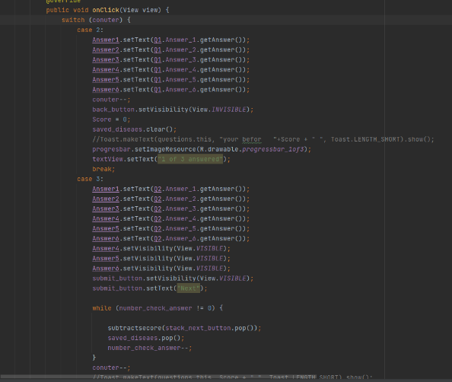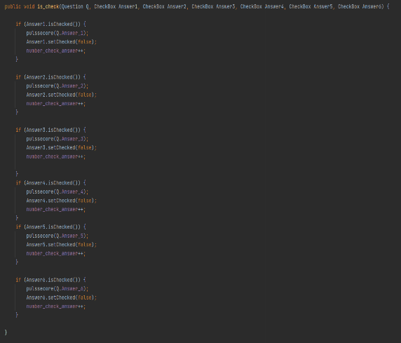

In figure ( ) this implementation of Questions and how we calculate the score to check if

He/she has the corona virus or not .

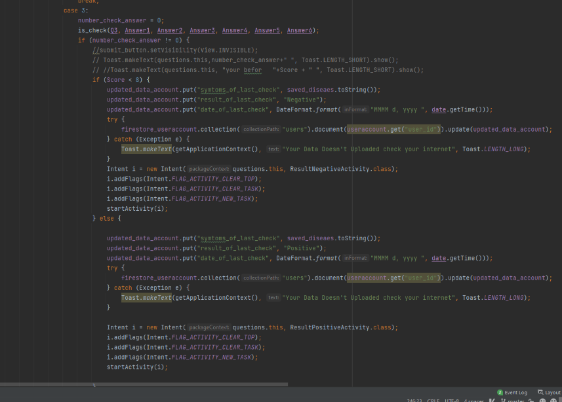

After performing the test and click on  
 result the user will go to the result   
screen to see his/her result.

In figure ( ) the implementation of   
the result button and how answers that   
the user chose it and his/her results   
sent to firebase ,And saved on it.

Result screen

After the user answer the questions we have two ways:

* Positive means that user have the virus
* 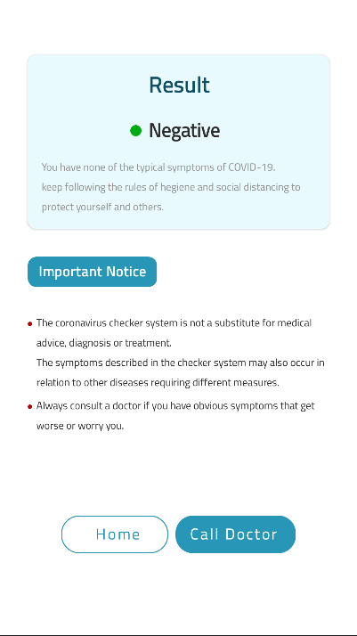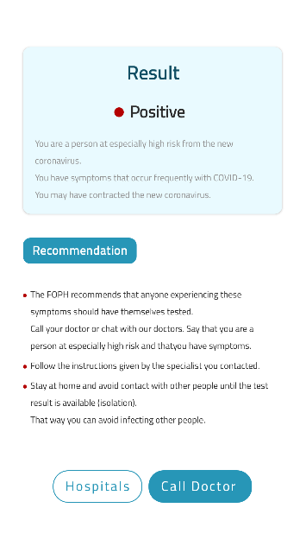 Negative means that user didn’t have the virus.

After check user have to ways:

1. Back to home screen
2. Call the doctor

## Call doctor

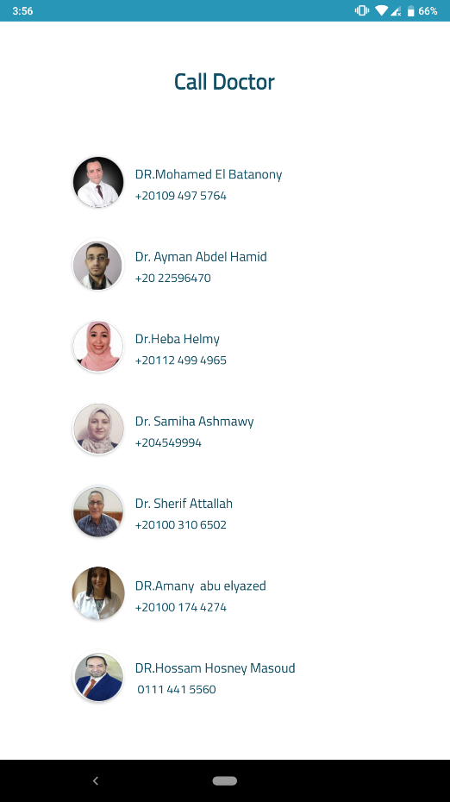

Here we can the design of Call doctor activity in figure ( )

this get the result from fire base and if click of any

doctor’s number , the app will open the phone app and if the

user want to call this doctor now or not

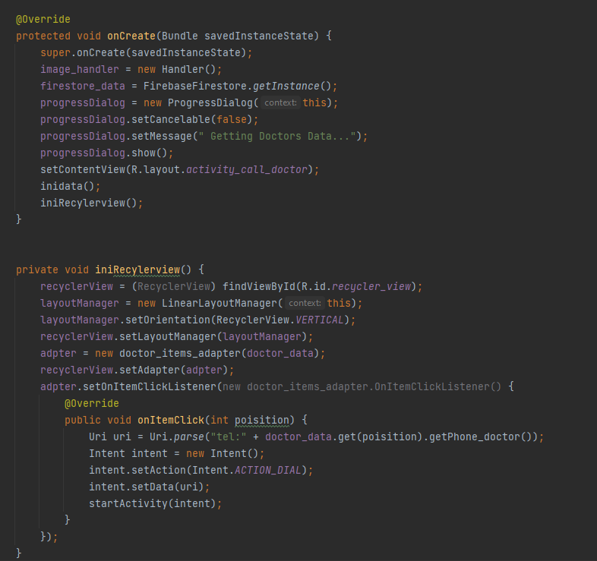

In figure ( ) we can see the implementation of this activity and see how the data of doctor is got from the firebase and displayed in recycler view

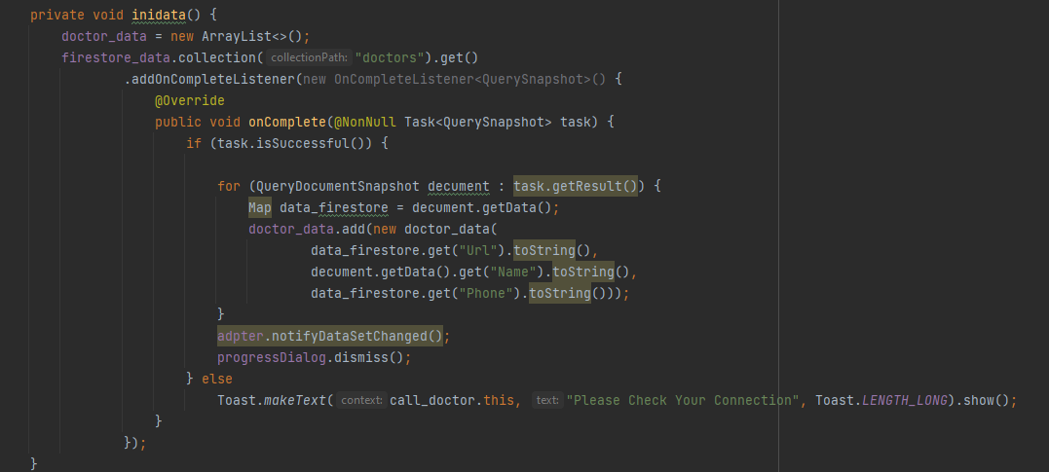

Now we can get data from firebase and initial to recycler view and displayed on call doctor activaty

## Hospitals

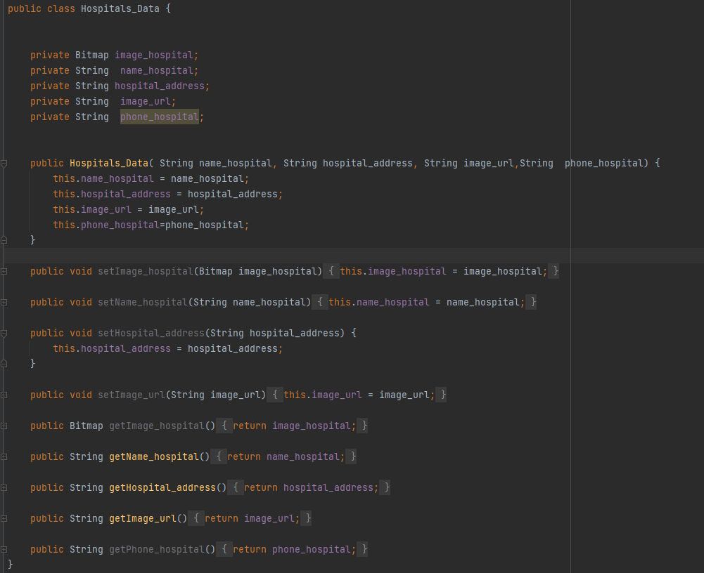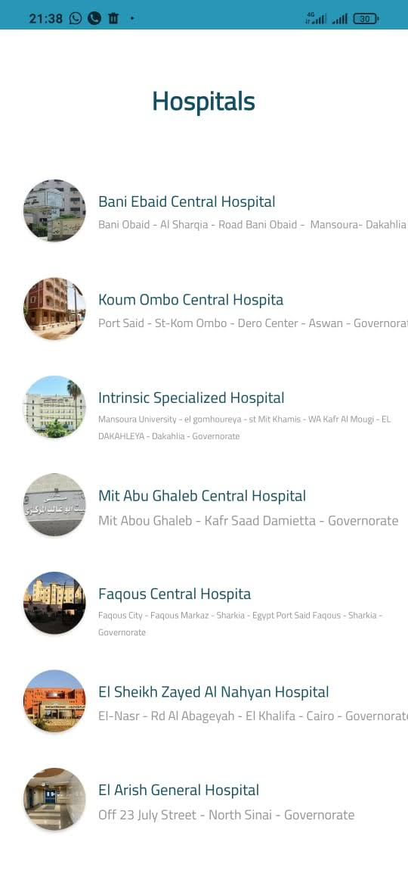

Here this is the implementation of Hospital Activity and it is the same of call doctor but we change the class data and we display it in figure ( )   
this data come from firebase and display on recycler view on hospitals Activity

## News screen

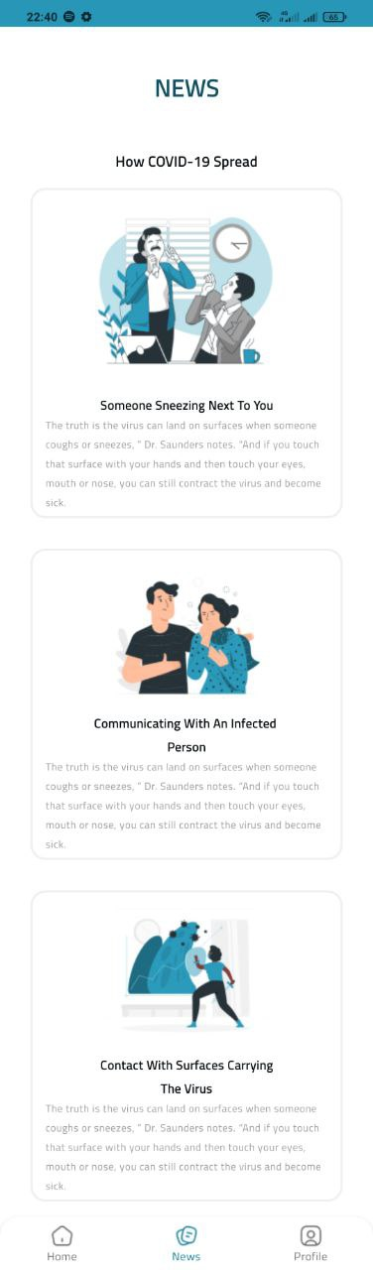

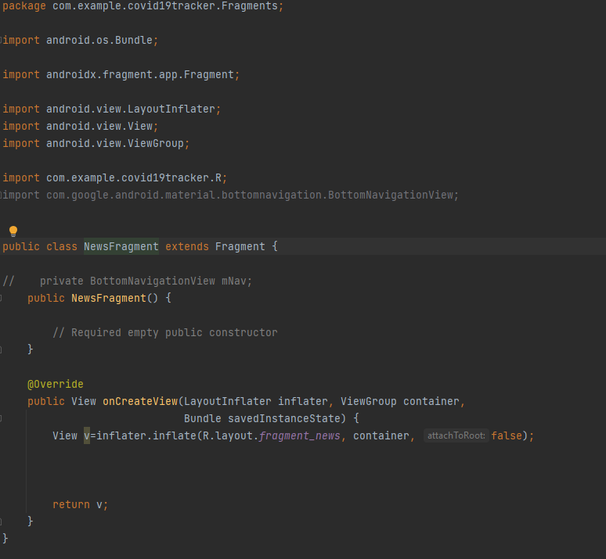

## Profile screen

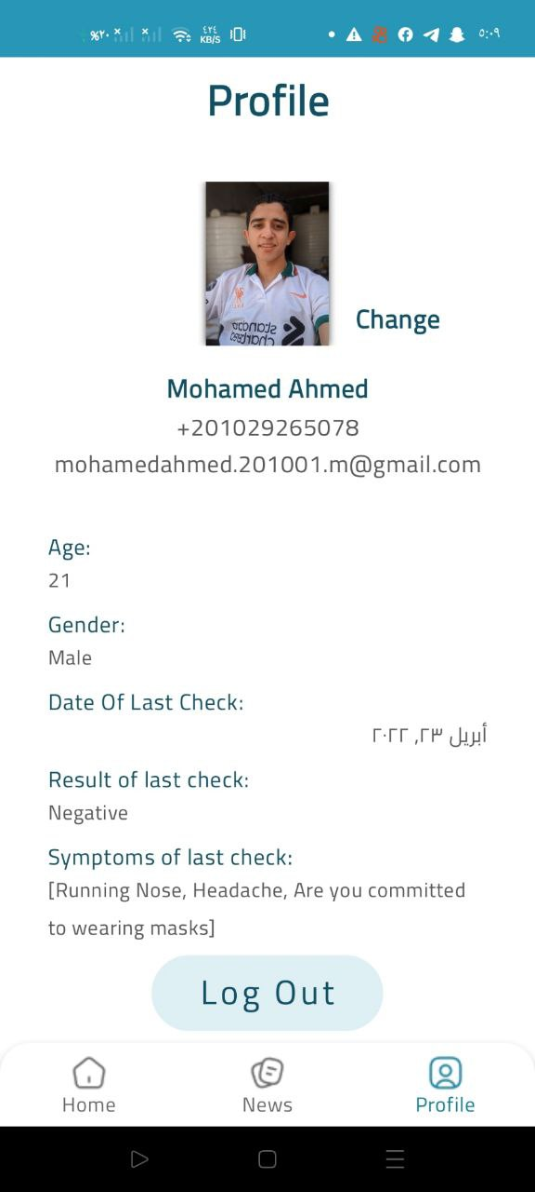In this screen we show the data that the user entered in sign up screen and the photo of the user he can change it. we grab it from firestore and we grab the result of last check

If the user press change click

1. The app will ask the permission to access the external storage
   1. If app has permission it’ll not ask for it
   2. If the user deny the permission will not continue
   3. 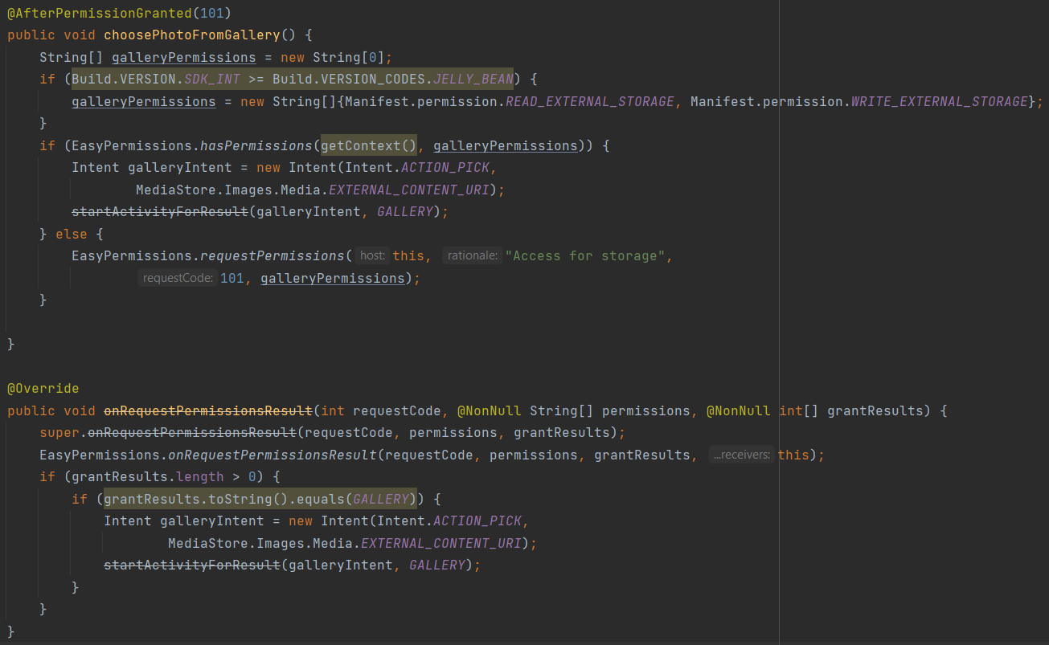If the user enter the permission the app can access the storage and take the photo then will upload it   
      first we get the permission then launch the activity then receive the photo in onActivityResult function

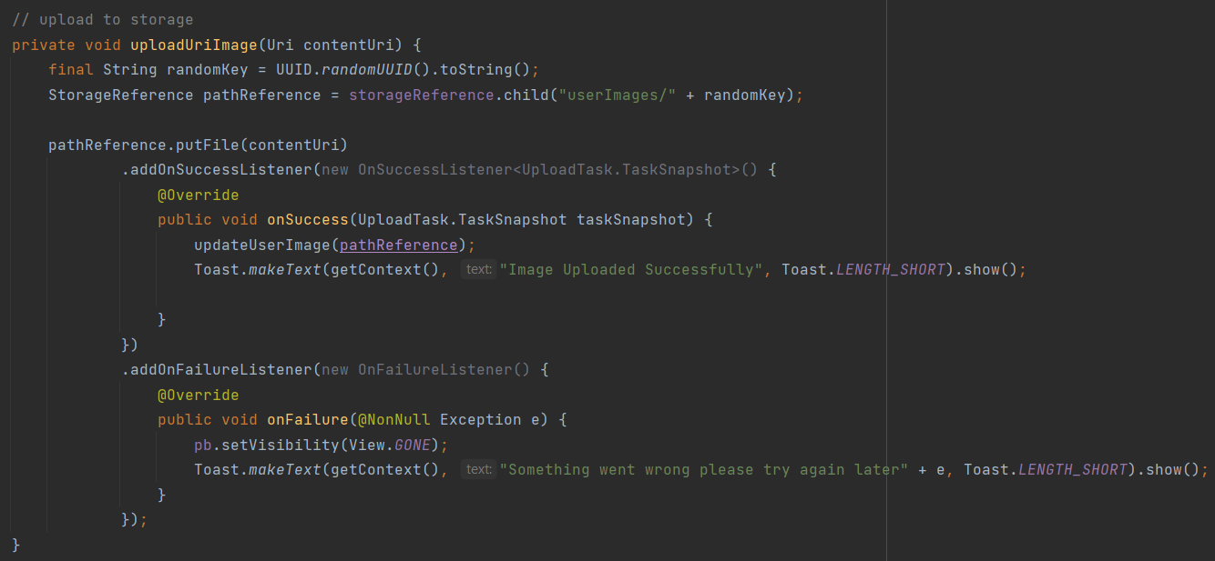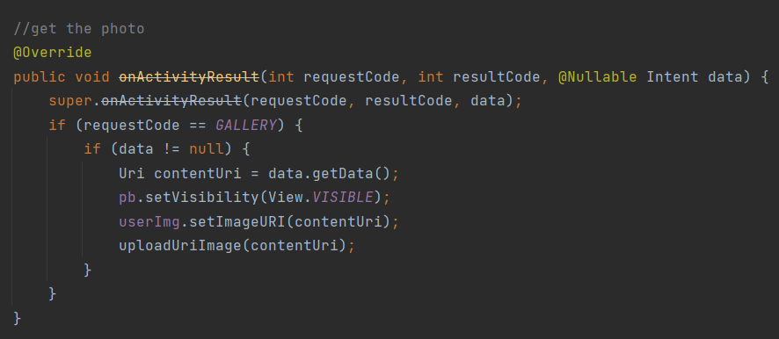we take the photo as uri image and then upload it into firebase storage to use it later from any device. We upload it use uploadUriImage() function

this function connect with firebase storage then upload thee image in directory userImages in the storage

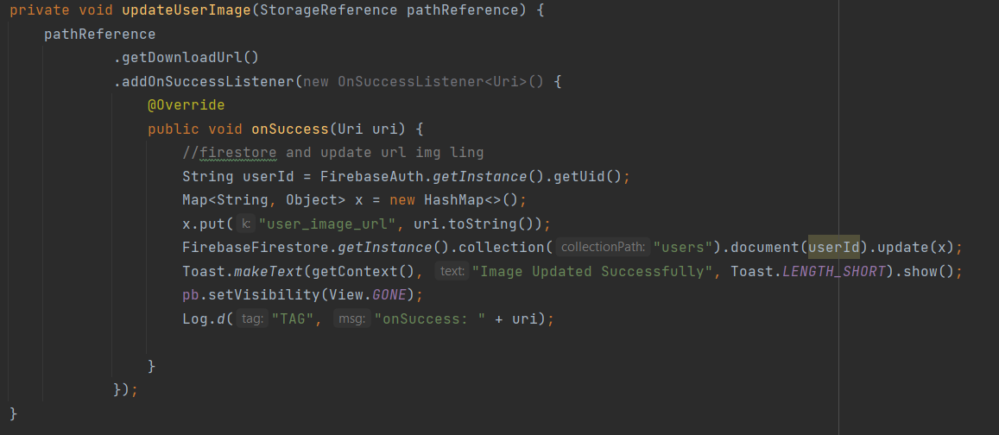after uploading it we need to get the url for it and update it in the user data so first we get the img link then update the user data in the fire store. We make updateUserImage() function to do that

first we download the url using getDownloadUrl() function

and if success we call the fire store to finally update the url.

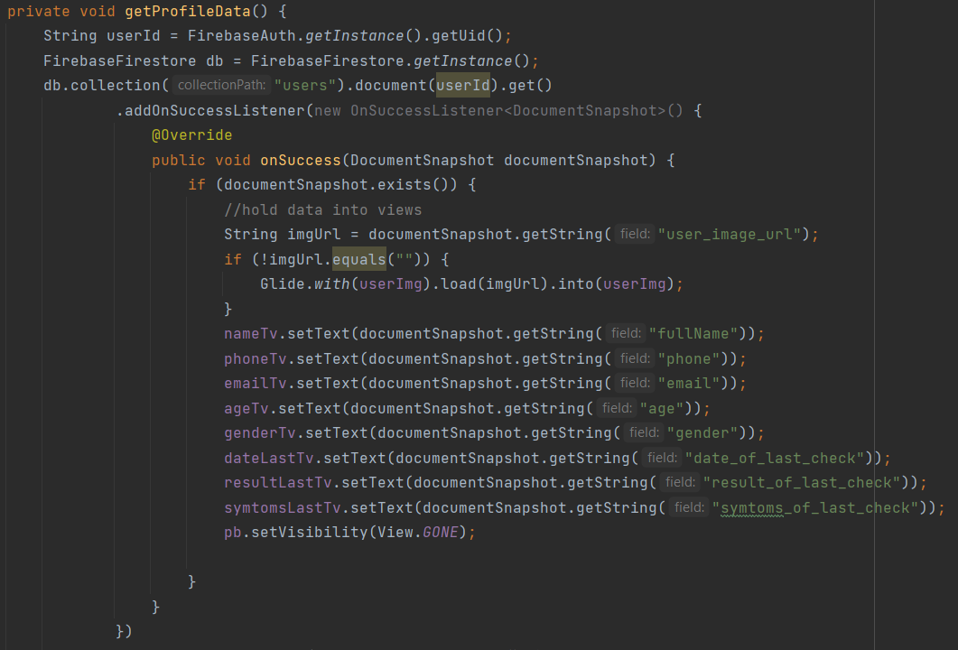After intiating views we use getProfileData() function to get the data and hold it into views

* First we get the user id from firebase and store it
* Then we access the document of the current user and get all data that stored
* And finally we view it in some view
* To get the photo we use its link and first we download it then use it
* If were problem the app will show a toast with the error which mostly bad connection

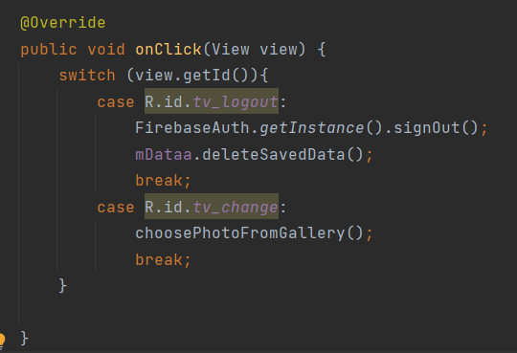The onClick() method have 2 buttons one for change photo which we explain it before and the other is the log out button

It’s a normal button that log out the user from the app and clear all data saved in shared preferences. We call fire base signout function and deleteSavedData() function that clear all data saved in shared preferences.